- Transaction Analytics
QUESTION
Berapa total volume dan nilai transaksi per hari, minggu, dan bulan? Apa tren pertumbuhannya?
QUERY
SELECT
period_type,
period_start_date,
total_transactions,
total_amount,
avg_transaction_amount,
success_transactions,
failed_transactions,
pending_transactions,
previous_total_amount,
growth_amount_pct
FROM mart_transaction_analytics
ORDER BY
CASE
WHEN period_type = 'DAY' THEN 1
WHEN period_type = 'WEEK' THEN 2
WHEN period_type = 'MONTH' THEN 3
ELSE 4
END,
period_start_date;
OUTPUT
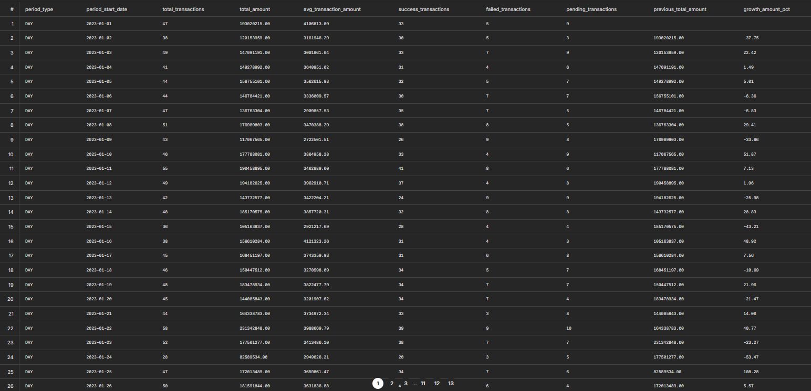

- Customer 360
QUESTION
Siapa nasabah paling aktif berdasarkan frekuensi dan nilai transaksi?
QUERY
SELECT
customer_id,
customer_code,
full_name,
segment,
job_segment,
city,
province,
total_transactions,
total_amount,
avg_transaction_amount,
max_transaction_amount,
active_days,
frequency_rank,
amount_rank,
customer_value_segment
FROM mart_customer_360
ORDER BY
total_transactions DESC,
total_amount DESC
LIMIT 20;
OUTPUT
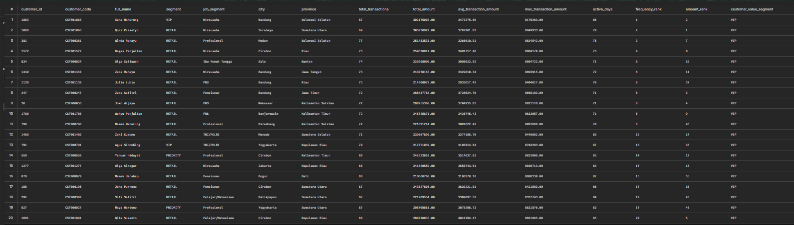

- Branch Performance
QUESTION
Cabang mana yang memiliki performa tertinggi berdasarkan jumlah transaksi dan total nilai transaksi per region?
QUERY
SELECT
region,
branch_id,
branch_code,
branch_name,
branch_type,
city,
province,
total_transactions,
total_amount,
avg_transaction_amount,
active_customers,
transaction_rank_region,
amount_rank_region
FROM mart_branch_performance
WHERE transaction_rank_region = 1
OR amount_rank_region = 1
ORDER BY
region,
transaction_rank_region,
amount_rank_region;
OUTPUT
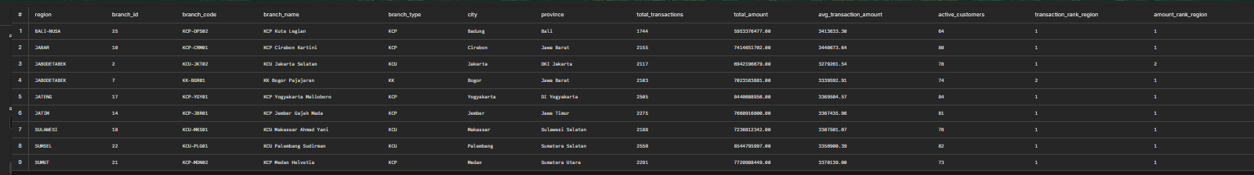

- Channel Analysis
QUESTION
Channel apa yang paling banyak digunakan nasabah?
QUERY
SELECT
channel_code,
channel_name,
channel_category,
is_digital,
channel_group,
SUM(total_transactions) AS total_transactions,
SUM(total_amount) AS total_amount,
SUM(active_customers) AS active_customers
FROM mart_channel_analysis
GROUP BY
channel_code,
channel_name,
channel_category,
is_digital,
channel_group
ORDER BY total_transactions DESC;
OUTPUT

- Product Performance
QUESTION
Produk rekening mana yang menghasilkan volume transaksi dan saldo rata-rata tertinggi?
QUERY
SELECT
account_type,
product_name,
currency,
SUM(total_accounts) AS total_accounts,
SUM(total_transactions) AS total_transactions,
SUM(total_amount) AS total_amount,
ROUND(AVG(avg_transaction_amount), 2) AS avg_transaction_amount,
ROUND(AVG(avg_balance_before), 2) AS avg_balance_before,
ROUND(AVG(avg_balance_after), 2) AS avg_balance_after
FROM mart_product_performance
GROUP BY
account_type,
product_name,
currency
ORDER BY
total_transactions DESC,
avg_balance_after DESC
LIMIT 20;
OUTPUT
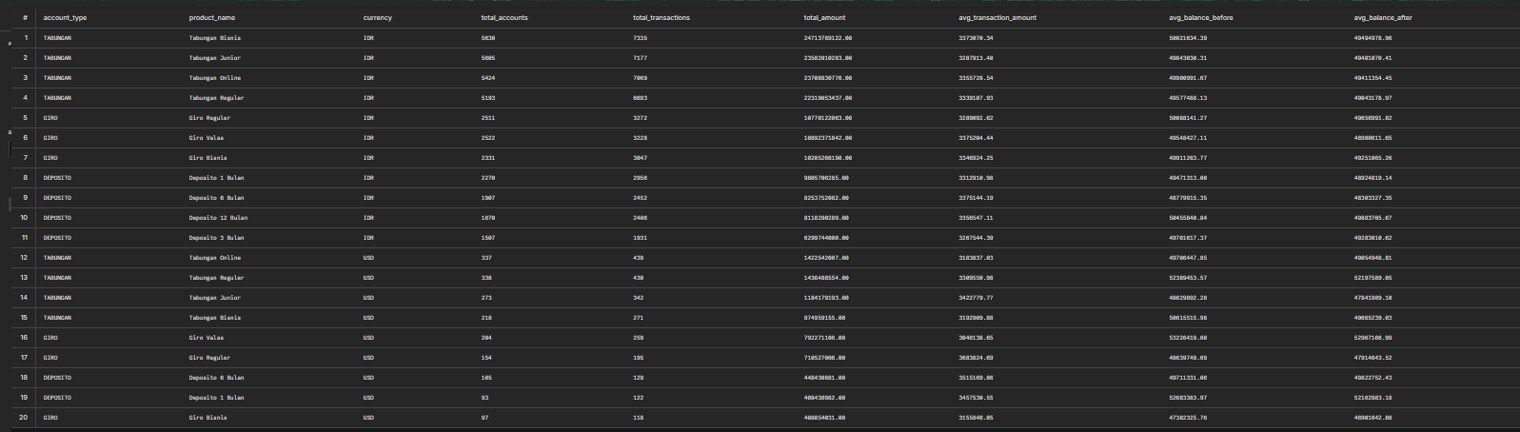

- Risk & Fraud Detection
QUESTION
Adakah transaksi anomali nilai sangat besar, frekuensi tidak wajar, atau status FAILED berulang yang perlu diwaspadai?
QUERY
SELECT
transaction_id,
transaction_code,
transaction_date,
transaction_at,
customer_id,
customer_code,
full_name,
segment,
channel_code,
channel_name,
transaction_type,
amount,
status,
risk_level,
anomaly_amount_flag,
high_frequency_flag,
repeated_failed_flag,
fraud_label_flag,
fraud_type,
fraud_score,
anomaly_reason
FROM mart_risk_fraud_performance
WHERE risk_level IN ('High', 'Medium')
ORDER BY
CASE
WHEN risk_level = 'High' THEN 1
WHEN risk_level = 'Medium' THEN 2
ELSE 3
END,
amount DESC
LIMIT 50;
OUTPUT
